The spread of flower symbolism from the Victorian language of flowers to modern flower emoji
Susan Loy
Artist and author of “Flowers, The Angels’ Alphabet: The Language and Poetry of Flowers”
The tradition of associating flowers with sentiments is ancient and universal, and the types of sentiments that flowers symbolize are similar from region to region. Individual flower associations, however, are not universal; there is not one lexicon of agreed upon meanings even within a single culture. In the past, symbolic flowers and their lexicons have been tied to the geography and customs of a region as well as to a deep connection with the plant kingdom. As humans lose this deep connection with nature and as the Internet replaces regional geography, flower associations are changing; they are losing their connection with the plant kingdom, while retaining some of the geographic and seasonal associations of the past. This study looks at the origins of symbolic flower languages; how through a cross-cultural migration of ideas and lore from Chinese, Middle Eastern and ancient Greek and Roman cultures, the idea of a language of flowers or floriography spread to France, England, and North America; how the genre of language of flower books evolved; and how the flowers derived their meanings. It considers recent trends in flower symbolism, continued use of the Victorian language of flowers, and emergence of symbolic flower emoji on electronic devices.

Flower symbolism
Early humans lived close to nature and developed a sensitivity to plants and trees, their use, form, color, scent, and even the sound they made blowing in the wind or as an animal brushed past. This close association with plant life was necessary for survival; it also fed human imagination, and flowers, trees, and plants took on symbolic meanings. The earliest records from Egypt, Sumer, and China contain plant information and give evidence of a long oral tradition. A tablet from Sumer (modern day Iraq and Kuwait) from about 3000 B.C. lists about a dozen items, including cassia, figs, and thyme, with their associated cures. The earliest herbals from about 1550 B.C. contained material from five to twenty centuries earlier, and in China, a compilation of oral traditions dating back centuries was produced about 200-250 A.D. (Anderson, 1977). The first herbal in Greece was written in the 3rd century B.C. The single most influential herbal ever written, a product of the classical world of Greece and Rome, was written by Dioscorides about 65 A.D.
Beginning in the 7th century A.D., ancient Chinese flower calendars established the tradition of associating seasonal flowers with sentiments or meanings. For example, the flower of January and Winter was the plum blossom, a symbol of beauty and longevity. The flower calendars spread to Japan and the Middle East and eventually to Europe and North America. Ancient Greeks and Romans began giving seasonal flowers as birthday gifts. By the 1700s the idea of sélam, the Turkish language of flowers and objects, reached Europe, further establishing the notion of associating flowers with meanings. The idea of a symbolic language of flowers or floriography made its way to Victorian Europe and North America through a cross-cultural migration of ideas and lore from China, Japan, Turkey, Greece, and Rome.

Folklore, mythology, and religion
Humans had to learn which plants were edible and which were poisonous, which were medicinal or otherwise useful, and how to identify them. This close association with plant life fed human imagination, and plants have developed into symbols for human expression. Trees were among the first plants to take on symbolic form. Myths from all over the world have featured trees: Zeus was worshipped as a sacred oak, and in Norse mythology the Yggdrasil, an evergreen ash tree, was a symbol of the life-giving force of nature (Friend, 1886). To explain human origin, early humans observed the tree, how it expands its branches and unfolds its leaves, and took it as a symbol of life. Symbols of the Tree of Life, known variously as the Cosmic Tree, Mundane Tree, Tree of Immortality, the Tree of Knowledge, Tree of Temptation, World Tree, and Universe Tree, have been adopted by many beliefs and religions in the world. The sacred tree of Buddha is the pipal or bo tree (Ficus religiosa). It is said that Vishnu, second of the triad Brahma, Vishnu, and Shiva, was born under the banyan tree (Ficus indica). The Persian Haoma tree was a symbol of immortality. The Tree of Knowledge has figured prominently in visions of paradise such as in the biblical Garden of Eden.
Classical Greek and Roman mythology is the source of much flower lore, often metamorphic stories where gods or mortals are turned into a flower. Flowers have become symbols of seasons and months of the year, and have been associated with gods, goddesses, and other deities as well as saints, heroes, kings, and queens. They have been used in heraldic devices and flags and have become an integral part of religious ceremonies such as weddings and funerals, and special days or events such as anniversaries, birthdays, Mother’s Day, and Valentine’s Day.
Religious traditions are rich with flower symbolism. An emblem of perfection and purity, the lotus has been an important symbol. Roots and seeds of the lotus have been used in cooking since prehistoric times and may have helped elevate its status. It was a symbol of the Egyptian Sun God, Horus, who is said to have been born in a lotus; likewise, it appeared in Hindu legends where many of the Hindu gods were said to have been born in a lotus flower; and the Buddha is often shown seated on a lotus in the lotus position. Early Christian leaders eschewed the symbolic use of flowers because they viewed the custom as pagan, but this view did not prevail, and by the 4th century flowers were used for Christian weddings, funerals, and church decorations. The white or Madonna lily became associated with Mary, a symbol of purity, and is also associated with Easter. Flowers associated with Christmas became popular and have included: winter aconite (Eranthis hyemalis), known to the French as rose de Noel and to the Germans as Christwurzel, Christmas rose (Helleborus niger), as well as ivy, holly, mistletoe, and evergreen trees. Poinsettias became popular Christmas flowers during the 20th century. During the Middle Ages some religions created calendars of saints for every day of the year with a flower associated with each saint (Shoberl, 1839).

Flower calendars
The oldest know calendars featuring the Flowers of the Month came from ancient China. According to Chinese legend, in the 7th century Ho Hsien-ku, the daughter of a shopkeeper in Hunan Province, ate a peach of immortality given to her by the god of longevity, Canopus. She became one of the eight Taoist immortals, the goddess or genius of flowers, and proclaimed that recognition should be paid to a special flower for each month (Lehner, 1960). This Chinese flower calendar is probably the oldest of its kind and throughout the centuries has been copied and spread around the world (Table 1). In the Chinese tradition each flower carries a symbolic meaning for example, peach blossom, flower of February, was a symbol of marriage; the tree peony, flower of March, was a symbol of love and affection, and the lotus, flower of July, was a symbol of perfection and purity.
Table 1. “Flowers of the Month” in China, Japan, and England and North America (Lehner, 1960 and Krythe, 1966).
Month | China | Japan | England and North America
January | Plum blossom | Pine | Snowdrop or carnation
February | Peach blossom | Plum | Primrose or violet or iris
March | Tree peony | Cherry | Violet or daffodil or jonquil
April | Cherry blossom | Wisteria | Daisy or sweet pea
May | Magnolia | Iris | Hawthorn or lily of the valley or lily
June | Pomegranate | Peony | Honeysuckle or rose
July | Lotus flower | Mountain clover | Waterlily or larkspur or delphinium
August | Pear Blossom | Hill and moon | Poppy or gladiola
September | Mallow blossom | Chrysanthemum | Morning glory or aster or forget-me-not
October | Chrysanthemum | Maple | Hop or calendula or cosmos or marigold
November | Gardenia | Willow | Chrysanthemum
December | Poppy | Paulownia | Holly or paper-white narcissus or poinsettia

Like Chinese culture, Japanese culture is rich in flower symbolism. Ikebana, the Japanese art of flower arrangement, has its roots in Buddhism from the custom of offering flowers at an altar of Buddha. Japanese Buddhists began to present their offerings in containers in symbolic arrangements, and by the middle of the 15th century classical styles of Ikebana began to be established. Popular card games evolved with twelve suits representing the symbolic Japanese Flowers of the Month such as the flowers, listed in Table 1, from Hana-awase, a flower-pairing game (Lehner, 1960).
In the Western world, ancient Romans started celebrating birthdays using seasonal flowers as gifts. Although calendars from Medieval Europe focused on agricultural activities to represent the months, by the 18th century, European calendars began adopting the custom of symbolizing the months with seasonal flowers and plants that were common in Europe. North American calendars followed suit. Table 1 lists the Flowers of the Month that have been adopted in England and North America, but it should be noted that these calendars can be variable.
The ancient Chinese flower calendar helped to establish flowers as symbols of the seasons and months and also conveyed the idea that individual flowers have symbolic meaning. Flowers of the Month calendars from different regions of the world reflect the flowers, trees, and shrubs that would be blossoming in the appointed month or season. Each of these flower calendars shows the deep connection to flowers and nature that these cultures share.

Sélam
Sélam is the Turkish language of flowers or objects, a mnemonic system whereby the flower or object rhymes with a standard line as an aid to remember that line. Examples do not translate well because of the rhyme, but an illustration would be “Ingi–Sensin guzelerin gingi” or “Pearl–A fair young girl” (Eliot, 1993). Two individuals are credited with introducing sélam to Europe: Aubry de la Mottraye and Lady Mary Wortley Montagu. Mottraye’s account of his visit to the court of Charles XII of Sweden, in exile in Turkey, was published in 1727 and immediately translated into English in 1732. Montagu accompanied her husband, the ambassador to Turkey, to his post in 1717. Her Turkish Embassy Letters were published in 1763, shortly after her death, and made her famous. The letters described Turkish life, including sélam (Halsbad, 1967). Although sélam is a mnemonic system, it became known in Europe as a system of associating flowers with sentiments.

Language of flowers books
The language of flowers was formalized during the Victorian era in England, France, and North America with the publication of hundreds of books that included lists of flower, herb, tree, and plant names and their associated meaning or sentiment. The idea of a language of flowers came together through a cross-cultural migration of ideas and lore from Chinese, Middle Eastern and ancient Greek and Roman cultures. These influences gave impetus to the creation of hundreds of language of flowers books.

“The language of flowers”
The earliest literary record of the phrase “the language of flowers” may be Christopher Smart’s line in Jubilate Agno, written 1759-63: “For there is a language of flowers. For there is a sound reasoning upon all flowers. For elegant phrases are nothing but flowers.” By the early 1800s, the phrase, “language of flowers,” was commonly recognized in Europe, and lists of flowers with their symbolic meanings began to be hand copied (Seaton, 1995). The phrase, “the language of flowers,” can refer to a general way in which flowers symbolize meanings or sentiments; however, most often it refers to the Victorian era literary tradition. The publication of Charlotte de Latour’s Le langage des fleurs in December 1819 was the beginning of the great proliferation of language of flowers books. Widely popular, her book stimulated the publishing industry, especially in France, England, and the United States, but also in Belgium, Germany, and other European countries as well as in South America.

The literary almanac
The roots of the language of flowers book are in an old genre of books, called almanacs. The literary almanac first included a calendar and was published as a New Year’s gift book. Soon the calendar was dropped, making the book suitable for other occasions, and it evolved into the gift flower book. Literary almanacs were published as early as 1765 in France and 1770 in Germany and reached their peak of popularity in Europe and the United States from about 1820 through 1860 (Seaton, 1995).
A typical language of flowers book contained a “dictionary” of flowers with their associated meanings or sentiments; for example, rose: “love.” Most books included a corresponding dictionary of sentiments to find the appropriate flower; for example, “thoughts of absent friends:” zinnia. Most books also included poetry either about flowers or about the sentiments they represent. Some books included botanical information, plant lore, and other details about the flowers and plants. A few books had floral calendars or a fortune-telling game, called a floral oracle. Many books contained illustrations, typically one to six color plates.
France. According to Seaton (1995), the first language of flowers book was probably B. Delachenayes’s Abécédaire de Flore ou language des fleurs (1810); the author drew upon three hand-copied lists for his floral lexicon. Alexis Lucot’s Emblêmes de Flore et des végetaux (1819) soon followed and contained an alphabetical listing of plants, a brief description, and its meaning. Lucot’s book was virtually unknown, but not unknown to Charlotte de Latour, who borrowed heavily from Lucot and other lists (Seaton, 1995). Her Le langage des fleurs (1819) was widely popular and contained a list of plants and their meanings and was organized around the seasons and months with detailed descriptions of the flowers and their meanings, and also included color plates by the famous miniaturist, Pancrace Bessa. It was published in several large and small volumes with two volumes printed on special paper. Figure 1 shows the opening color plates of the 3rd edition of Le langage des fleurs (1834).
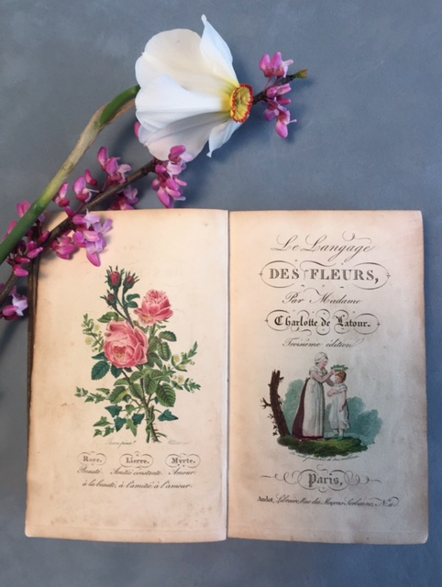
Figure 1. Opening pages of Charlotte de Latour’s Le langage des fleurs, 3rd edition, 1834.
England. The first language of flowers books in England were Henry Phillips’s Floral Emblems (1825) and Frederic Shorberl’s The Language of Flowers: With Illustrative Poetry (1834); both presented translations of de Latour, although Phillips added new flowers. Shorberl’s book was reprinted several times, including an American edition in 1839. Robert Tyas’s The Sentiment of Flowers; or, Language of Flora (1836) borrowed from de Latour as did Thomas Miller’s The Poetical Language of Flowers; or, The Pilgrimage of Love (1847); these books were also reprinted in England and the United States. Henry Adams’s The Language and Poetry of Flowers (1844) borrowed from de Latour but also consulted Elizabeth Gamble Wirt, adding new plants from North and South America and new meanings. Adams’s book was especially popular in the United States, where several editions were published. Today, one of the most familiar language of flowers books worldwide, is Kate Greenaway’s The Language of Flowers (1884). It has been translated into several languages and is being reprinted to this day. Greenaway was a popular children’s book illustrator, and drew upon previous writers, especially Adams, for her meanings.
North America. The first appearance of the language of flowers in print in the United States was in articles written by Constantine Samuel Rafinesque from 1827 to 1828 and published in the weekly Saturday Evening Post and monthly Casket; or Flowers of Literature, Wit, and Sentiment (Seaton, 1995). Elizabeth Gamble Wirt’s Flora’s Dictionary (1829) was the first American language of flowers book; in the preface she stated that her list was compiled from several lists, undoubtedly influenced by de Latour and Phillips; however, Wirt added many original meanings as well as new flowers, some with origins in North and South America.
Many well-known women editors and writers of the period created books. Sarah Josepha Hale drew upon de Latour and Wirt for Flora’s Interpreter; or, The American Book of Flowers and Sentiments (1832), revised as Flora’s Interpreter and Fortuna Flora (1848), which continued in print through the 1860’s. Frances Osgood’s The Poetry of Flowers and Flowers of Poetry (1841) and Lucy Hooper’s The Lady’s Book of Flowers and Poetry (1841) had very similar dictionaries that drew upon de Latour, Phillips, Shoberl, and Wirt. C. M. Kirtland’s Poetry of Flowers (c. 1882) presented one of the most comprehensive language of flowers books at 547 pages, drawing upon de Latour, Wirt, and especially Adams, Kirtland added some new plant species such as Magnolia glauca, a North American species, meaning “magnificence” and rose leaf: “you may hope” to the rose’s lexicon; Kirtland also added new meanings such as “deceit” to geranium, “anger” to furse, and “depart” to dandelion. Many other books were published through the century; George Daniels’s The Floral Kingdom: Its History, Sentiment and Poetry (1891), a large book with color plates, built upon previous lists and also added several new flowers and meanings (Figure 2).
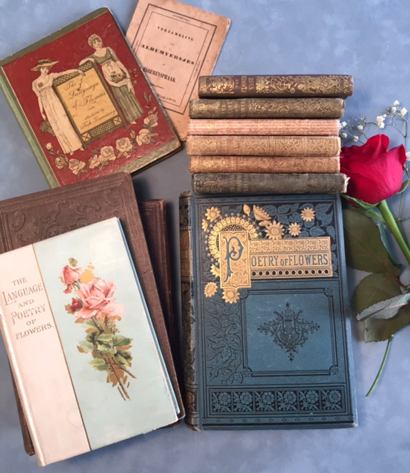
Figure 2. Victorian language of flowers books (clockwise from top left: Kate Greenaway’s 1884 “The Language of Flowers” overlaying van Zweeden’s 1842 “Albumbersjes en Bloemenspraak”; six 4-1/2” x 3” books atop Kirtland’s “Poetry of Flowers,” c. 1882; and Catherine Klein’s “The Language and Poetry of Flowers,” c. 1900).

Sources of flower symbolism
Perhaps the most common source of symbolism comes directly from some distinguishing characteristic of the plant—its blossom, color, leaf, name, orientation, root, season, seed, or stem. Color, for example, influences the tone of the sentiment. The rose has dozens of sentiments by color and type: red rose means “love,” while a deep red rose means “bashful shame,” a dried white rose means “death is preferable to loss of innocence,” a red-leaved rose means “beauty and prosperity or diffidence,” a white rose means “I am worthy of you, sadness, secrecy, silence, or too young to love,” white and red means “unity,” yellow rose means “jealousy,” red rosebud means “pure and lovely,” and white rosebud means “the heart that knows not love.”
Literature has provided symbolism to some flowers. Table 2 names a few. The most famous example is from Shakespeare’s Hamlet, Act IV, Scene V, spoken by Ophelia, “There’s rosemary, that’s for remembrance: pray you, love, remember: and there is pansies, that’s for thoughts…. There’s fennel for you, and columbines: there’s rue for you; and here’s some for me: we may call it herb of grace o’ Sundays. O, you must wear your rue with a difference.”
Other sources of symbolism have included folklore and mythology, religion, and history. Table 2 provides examples of each type. The Victorian meanings for a given flower could be quite varied, and it is rare when a majority agreed on one meaning. Overlap existed among the dictionaries because the writers copied each other. There were also discrete listings. In my book on the language of flowers (Loy, 2001), I include an appendix that aggregates the lexicons of 17 language of flowers books, published 1819-1891, including British, North American, and a translation of de Latour’s French dictionaries. The appendix reveals how varied the meanings were. For example, primrose has nineteen listings as follows (with the number of listings in parenthesis): childhood (2), early youth (9), have confidence in me (1), modest worth (1), sadness (1), unpatronized merit (4), and youth (1). Sweet William has fifteen listings: childhood (1), craftiness (2), dexterity (1), finesse (4), gallantry (4), smile (2) stratagem (1). Many of the meanings are synonyms. Some of the meanings have no connection with previous lists or with traditional sources for their meaning and seem to represent the whim or fancy of the writer like the examples in Table 2.
Table 2. Common sources of flower symbolism.
Plant Morphology or Characteristic | Namesake
Blossom
Amaranthus  (Amaranthus) | From the Greek word amaranthus, which means unfading, because the flowers retain their color for a long time; one of its meanings in the language of flowers is unfading.
Columbine  (Aquilegia vulgaris) | Signifies folly because the shape of the blossoms resembles a jester’s cap.
Pansy  (Viola tricolor) | From the French word, pensée, meaning “thoughts” because the showy blossom is often likened to a face.
Rose campion  (Lychnis coronaria) | Means you are without pretension because of the flower’s unassuming quality.
Characteristic
Barberry  (Berberis vulgaris) | Gets its meaning of sourness from its sour taste.
Dogwood  (Cornus florida) | Means durability and is from the Latin word kornu, a horn, so named because horns are made out of hard wood.
Heliotrope (Heliotropium peruviannum) | Means turning toward the sun because it was believed that the blossoms turned to the sun, a sign of its devotion.
Ice plant  (Mesembryanthemum crystallinum) | Looks like it is scattered with frozen crystals when exposed to the sun and feels cold to the touch, thus its name, ice plant, and its Victorian meaning, your looks freeze me.
Honey flower  (Melianthus major) | From the Greek for meli, honey, and anthos, a flower, so named because the flowers are very sweet; it means love is sweet and secret.
Mushroom  (Fungus) | Means suspicion because some species are poisonous and must be treated with suspicion.
Stinging nettle  (Urtica) | Means cruelty because the leaves and stems release formic acid when touched, causing stinging.
Thyme (Thymus) | Means activity because it attracts a lot of bee activity.
Color
Cardinal flower  (Lobelia cardinalis) | Named for its resemblance to a cardinal’s robe; means distinction and reflects the cardinal’s distinction.
China aster  (Callistephus chinensis) | Means variety because of its great variety of color, from white, yellow, pink, crimson, blue, to purple.
Love-lies-bleeding  (Amaranthus caudatus) | Named for its showy tassels of red flowers, means hopeless, not heartless.
Function
Alfalfa or lucerne  (Medicago sativa) | Means life because it is an excellent food for cattle and humans.
Flax (Linum usitatissimum) | Is a symbol of domestic industry because of its domestic uses.
Meadowsweet  (Spirea ulmaria) | Signifies uselessness because herbalists could find no use for it and animals wouldn’t eat it.
Poison Hemlock  (Conium maculatum) | Means you will cause my death in reference to Socrates, who is said to have been poisoned by hemlock.
Tansy  (Tanacetum vulgare) | Means resistance because it was used to prevent the spread of contagious diseases.
Wheat (Triticum) | Became a symbol of riches because of its nutritional value.
Stonecrop  (Sedum acre) | Means tranquility because it was thought to give protection from lightening when planted on cottage roofs.
Habit
Bryony  (Bryonia dioica) | From the Greek bruo, to grow luxuriantly, which may be why it means prosperity.
Bindweed  (Convolvulus) | From the Latin word convolvo, to entwine, which is one of its meanings.
Four-o’clock Plant  (Mirabilis jalapa) | Opens at 4 o’clock in the afternoon, and signifies time in some dictionaries.
Honeysuckle  (Lonicera periclymenum) | Means bonds of love because of its clinging habit.
Scarlet Pimpernel  (Anagallis arvensis) | Was in the Shepherd’s Clock because the flowers were reputed to open promptly at 7 a.m. and shut at 3 p.m. or when it rains. Because you can tell time with it, the Victorians made the scarlet pimpernel the symbol of assignation.
Sensitive plant  (Mimosa putica) | Became known as sensitive plant because its foliage is sensitive to the touch and means timidity.
Wallflower  (Cheiranthus cheiri) | Means fidelity in adversity because it grows in the cracks of walls in places where desolation prevails.
Leaf
Borage  (Borago officinalis) | From the Latin burra, a hairy garment, an allusion to the plant’s hairy leaves; one of its meanings is roughness of manner.
Catchfly (Silene) | From sialon, saliva, so-named because the gummy secretion of the leaves traps flies; it means to snare.
Name
Crown imperial  (Fritillaria imperialis) | Signifies majesty and power as it’s name suggests.
Enchanter’s nightshade  (Circaea lutetiana) | Signifies sorcery.
Eyebright  (Euphrasia nemorosa) | Signifies your eyes are bewitching.
Honesty (Lunaria annua) | Signifies honesty.
Traveller’s Joy  (Clematis vitalba) | Signifies safety.
Weeping willow (Salix) | Signifies forsaken, mourning, or melancholy.
Season
Autumn crocus  (Colchicum autumnale) | Means growing old because it blooms in the autumn of the year.
Lily-of-the-valley  (Convallaria majalis) | Heralds the return of spring and announces the return of happiness.
Michaelmas Daisy  (Aster) | Means afterthought because it blooms so late in the season, around St. Michael’s Day, September 29.
Scent
Jasmine  (Jasminum officinale) | Was found along ancient trade routes between the Middle East and China and was introduced to Britain in 1548. It means amiability because its fragrance is so pleasing.
Lemon (Citrus limonia) | Means zest because of its zesty flavor and scent.
Shape
Black Walnut  (Juglans nigra) | Means intellect because it resembles the brain.
Monk’s Hood or Helmet Flower  (Aconitum napellus) | Means knight errantry because it’s small yellow flower is surrounded by a whorl of leaves that resemble a hood or helmet.
Folklore and mythology | (Friend, 1886; Hamilton, 1942)
Adonis  (Adonis autumnalis) | Means painful recollections, alluding to Aphrodite’s grief over the death of Adonis.
Daisy  (Bellis perennis) | According to Roman legend, was named for the nymph, Belides, who in order to escape the attention of Vertumnus changed herself into the daisy, which means innocence or beauty and innocence.
Bilberry  (Vaccinium myrtillus) | Means treachery, alluding to Greek mythology where Mercury’s son Myrtillus’s treachery forced him to be turned into a bilberry bush.
Black poplar  (Populus nigra) | Means courage because of its association with Hercules, who sometimes wore a crown of black poplar leaves.
Evergreen cypress  (Cupressus sempervirens) | Means death or mourning in reference to the Greek legend of Cyparissus, who was turned into the cypress tree, becoming a symbol of eternal death.
Forget-me-not  (Myosotis palustris) | Means forget-me-not, remembrance, or true love. It has been the subject of many stories where the hero drowns trying to pick this flower. For example, in French legend Knight Roland drowned because of the weight of his armor but not before tossing the flower and calling out, “forget me not.” According to a Christian legend, it was named by God and became the symbol of remembering.
Hazel  (Corylus avellana) | Means reconciliation in reference to Greek mythology where Mercury, the god of eloquence, and Apollo, the god of harmony, exchanged gifts. Apollo gave Mercury a wand made of hazel, and the winged hazel entwined with two serpents became a symbol of peace and reconciliation.
Heliotrope (Heliotropium peruviannum) | Means devotion in reference to the water-nymph Clytie’s devotion to Apollo, god of the sun.
Hyacinth  (Hyacinthus orientalis) | Means grief or sorrow. In Greek myth, Hyacinthus, son of the King of Sparta, fell in love with Apollo and aroused the jealousy of Zephyr, who killed him; from his blood arose the flower that bore his name.
Iris (Iris) | Means message in the language of flowers because in classical mythology Iris, goddess of the rainbow, was the messenger of the gods.
Linden Tree  (Tilia vulgaris) | Became the symbol of conjugal love in reference to the legend of Philemon and Baucis.
Narcissus  (Narcissus poeticus) | Means egotism or self-love and relates to the story of Narcissus, a classic metamorphic story, where Narcissus pined away for love of his own reflection in a pool and when drowned, the flower that bears his name sprang up where he died.
Pomegranate  (Punica granatum) | Means foolishness because Proserpine was foolish enough to eat one in the underworld, forcing her to spend six months of the year with Pluto.
Rose (Rosa) | Rose has long been a symbol of love. According to Greek legend, Aphrodite, Apollo, Chloris, Dionysius, and Zephyr all contributed to the creation of the rose, the queen of flowers. Aphrodite presented the rose to her son, Eros, the god of love, and it became the symbol of love. When Eros gave the rose to Harpocrates, the god of silence, the rose became a symbol of silence.
Windflower  (Anemone coronaria) | Means frailty because, when abandoned by Zephyr, Anemone was too frail to withstand the north wind, Boreas. An alternative meaning is anticipation because, Venus, urged by Zephyr, turned the dead Anemone into a flower that always comes to life in spring.
Yarrow  (Achillea millefolium) | Named for the Greek hero, Achilles, and derived two meanings from Achilles: one is war because of his association with the Trojan war; the other is cure because Achilles used the plant to heal his soldiers.
Religion | (Lehner, 1960)
Carnations (Dianthus caryophyllus) | According to Christian legend, appeared on earth from the tears shed by Mary on the way to Calvary; the pink carnation became the symbol of mother-love, translated by the Victorians into woman’s love; it was named the emblem of Mother’s Day in 1907.
Hawthorn  (Crataegus monogyna) | Has been a symbol of hope since ancient times when Greek brides carried hawthorn blossoms to the altar of Hymen, the god of marriage; it means hope in the language of flowers.
Lily  (Lilium candidum) | Is a symbol of purity. Lilies were used in marriage ceremonies as a symbol of purity and adopted by the Christian Church as the Virgin Mary’s flower; they have also been associated with Easter.
Olive  (Olea europa) | Is a symbol of peace; the story of the dove returning to Noah’s Ark with an olive branch is one of the most famous Bible stories.
Orange blossoms  (Citrus sinensis) | Means chastity or bridal festivities because of its association with chaste brides.
Passion Flower  (Passiflora caerulea) | Was named by Jesuit priests. Flos Passionis or Flor de las cinch Ilagas, flower of the five wounds, means faith or religious fervor.
Speedwell  (Veronica officinalis) | Is a symbol of fidelity or female fidelity and was named after St. Veronica, who, according to legend helped Christ on the road to Calvary.
Willow herb or Laurier Saint Antoine (Epilobium angustifolium) | Was named by the French after St. Anthony, the founder of monasteries, and became associated with celibacy.
Vervain  (Verbena officinalis) | Is the symbol of enchantment because of its association with Druids; it became known as the enchanter’s plant.
History | Friend, 1886; Lerner, 1960)
Acanthus  (Acanthus mollis) | Is a symbol of the arts in reference to the acanthus motif in Corinthian columns created by Greek sculptor and architect Callimachus in the 5th century B.C.
Broom (Genista) | Was part on the seal of Richard I when he became king in 1189. His family name Plantagenet was taken from the broom’s medieval name, Planta genista, and the motto beneath, Deus exalt at humbles (God exalts the humble), thus its significance, humility, in the language of flowers.
Fennel  (Foeniculum vulgare) | Was presented as garlands to victors in ancient Greece, thus its meaning, worthy of praise.
Flax (Linum usitatssimum) | Is a symbol of fate because flax was the hieroglyphic for fate in ancient Egypt.
Laurel or bay laurel  (Laurus nobilis) | Was used in ancient Greece and Rome to crown victors, heroes, philosophers, and poets, and it is from this practice that the title Poet Laureate derives; associated with Apollo, it has long been a symbol of glory.
Olive  (Olea europaea) | Has signified peace since barbaric tribes used an olive branch to concede defeat.
Plane tree  (Plantanus) | Was the symbol of genius because Greek philosophers held their discourses under them.
Rose  (Rosa gallica var. versicola) | Have figured prominently in history; the War of the Roses is the most notable. The House of Lancaster adopted the red rose, while the House of York wore a white rose. When the War of the Roses ended with the establishment of the House of Tudor, the red and white rose became a symbol of unity. The York and Lancaster rose also means war in the language of flowers.
Tamarisk (Tamarix) | Means crime because Romans used it to garland criminals.
Whim or fancy of the writer or editor | (Loy, 2001)
Evening Primrose  (Oenothera odorata)  Meadowsweet  (Spirea ulmaria)  Narcissus  (Narcissus poeticus) | Inconstancy was the meaning chosen by 14 writers because the flower’s bloom is so short-lived, while only one writer chose the meaning I am more faithful.  Uselessness was the meaning chosen by 8 writers because it was deemed useless, while only one chose the meaning praise.  Egotism or self-love was the meaning chosen by 13 writers because of its reference to Greek mythology, while only one writer chose the meaning disdain.
Literature
Rosemary, Pansies, Rue | William Shakespeare’s Hamlet, Act IV, Scene V: “There’s rosemary that’s for remembrance; pray you, love, remember: and there is pansies, that’s for thoughts.” The Victorians kept these meanings in their lexicon. Ophelia continued, “…there’s rue for you, and here’s some for me; we may call it herb of grace o’ Sundays.” Elizabethans associated rue, a bitter herb, with repentance, forgiveness, and grace, and the Victorians adopted the meanings of grace, purification, and repentance.
Bluebell  (Hyacinthoides nonscriptus) | Robert Burns gave the bluebell its meaning of constancy, “constancy with its unchanging blue.”
Gillyflowers, Marigolds, Cowslips, Lavender, Violet | William Hunnis’s 16th century poem, A Nosegay always sweet, for lovers to send for tokens of love at New Year’s Tide, or for fairings mentions “Gillyflowers is for gentleness, Which in me shall remain,” and “Marigolds is for marriage, That would our minds suffice,” and “Cowslips is for counsel, For secrets us between” and “Lavender is for lovers true” and “Violet is for faithfulness.” Violet means faithfulness; one of marigold’s meanings is sacred affection, and one of gillyflowers is woman’s love.
Lily, Violet | A 17th century carol known as King Jesus Hath a Garden included the lines, “The Lily, white in blossom there, is Chastity; The Violet, with sweet perfume, Humility.” The white violet signifies modesty, and the white lily is a symbol of purity.
Periwinkle | Rousseau related a story in which the periwinkle represented happy memories to him, and periwinkle (Vinca major or V. minor) became associated with happy memories.

Use of flower symbolism
Throughout the world, flowers have been an important part of ceremonies and rituals. Brides have included flowers in their weddings to symbolize love, and flowers have been prominent at funerals, conveying sympathy and compassion. Used to express love and friendship, flowers have been a favorite gift for holidays since ancient Roman times. Because it requires the appropriate flower to be in season as well as the appropriate dictionary, the Victorian language of flowers is not a practical language; there is very little evidence that the language of flowers was used for communication by Victorians or others, although many of the Victorian-era and modern writers say so. The language of flowers or floriography is a symbolic flower tradition that has and continues to be used by artists, designers, editors, florists, marketers, poets, and writers.
Poets have used the language of flowers in their poetry and written whole poems on the subject; the most famous are Elizabeth Barrett Browning’s “A Flower in a Letter,” Leigh Hunt’s “Love Letters Made of Flowers,” and Henry Wadsworth Longfellow’s “Flowers,” but also poems titled “Flowers” or “The Language of Flowers” by Sarah Carter Edgarton Mayo, Charles F. Hoffman, Park Benjamin, James Gates Percival, and Catharine H. Waterman Esling. Emily Dickinson created her own unique flower lexicon, but her girlhood botany book did include a language of flowers dictionary. She used meanings in very subtle ways: Clematis can signify traveller’s joy, so Dickinson wrote, “Clematis–journeying far” and, knowing that rosemary means remembrance, she described the memory of its fragrance. Shakespeare may have been responsible for Henry David Thoreau writing in his journal, “For a flower, I like the name pansy, or pensée, best of any… for thoughts,” or for Mark Twain and his character Tom Sawyer understanding that pansy means thoughts, when Becky Thatcher tossed a pansy over the fence.
The Pre-Raphelite painters incorporated flower symbolism into their paintings such as Dante Gabriel Rossetti’s The Annunciation of 1849-50 and John Everett Millais’s Ophelia of 1851-52. G.D. Leslie’s painting of 1885, The Language of Flowers, depicts two women with a basket of flowers, consulting a language of flowers book. Greeting card and postcard designers have used the language of flowers, often selecting individual flowers and sentiments such as pansy: thoughts or presenting the flower of the month with its meaning. Maurice Ravel created a ballet in 1911 based on the language of flowers, Adélaide ou le language des fleurs.

Recent trends in England and North America
Contemporary trends show that the language of flowers continues to be used by artists, designers, florists, marketers, and writers in isolated instances. I began using the language of flowers in my own Literary Calligraphy® art work in the mid-1980s when I hand-copied my first list in the rare book room of the University of Virginia and over time collected dozens of Victorian language of flowers books. I have created a series of watercolors and limited edition prints based on the language of flowers. Many feature an individual flower surrounded by a hand-lettered statement of the flower’s meaning and a poem or verse reflecting that meaning and/or flower. An example can be seen in Figure 3, my watercolor drawing of the red rose, Rosa gallica, and lettering of Robert Burns’s famous poem, “My luve is like a red, red rose.” Several larger watercolors include colorful wreaths with 26 plants, one for every letter of the alphabet, and their meaning in the language of flowers, as shown in Figure 4. This is an ongoing series of 30 watercolors that I am still adding to in 2016.
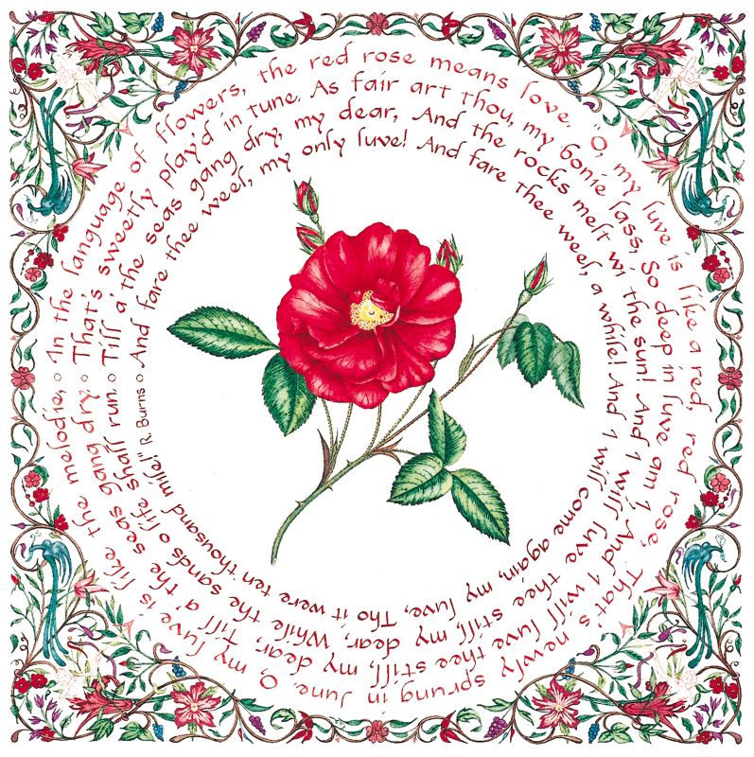
Figure 3. “Red Rose: Love” (Loy, 2001, used with permission).
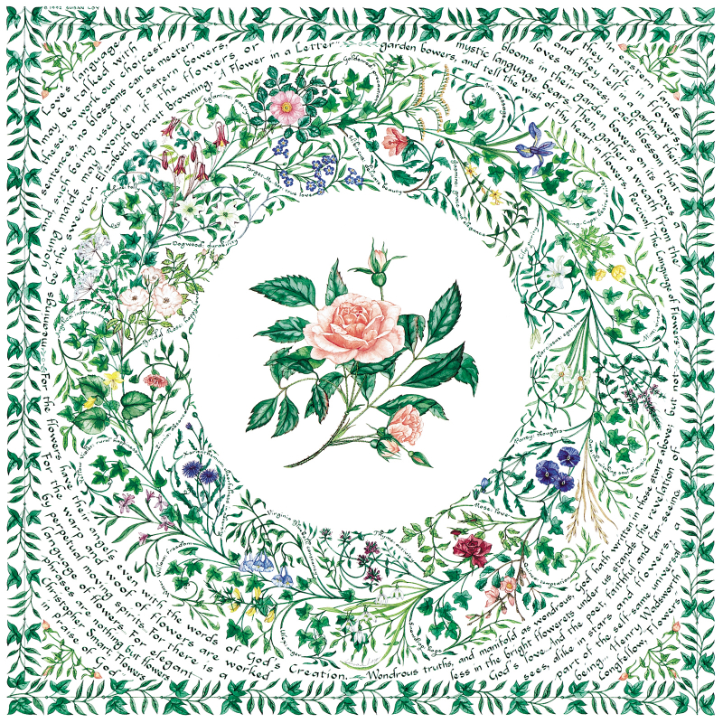
Figure 4. “Language of Flowers” (Loy, 2001, used with permission).
Books and E-books. New language of flowers books continue to be published. There was a noticeable spike in their publication starting in the late 1960s and continuing through the turn of the century. Margaret Pickston’s The Language of Flowers (1968) is a reproduction of a handwritten list nearly identical to Greenaway’s; reprinted numerous times, it is a small book and is widely available today. Dover Publications has republished Routledge’s 1884 edition of Kate Greenaway’s Language of Flowers (1992), available hardbound or in paperback. Sheila Pickles’s The Language of Flowers (1990) and Forget-Me-Not: A Floral Treasury (1993) are examples of hardbound gift books. My book, Flowers, The Angels’ Alphabet: The Language and Poetry of Flowers (2001) is hardbound and includes 28 color reproductions of my language of flowers series of watercolors as well as a comprehensive dictionary with 1400 flowers and their sentiments and 1500 sentiments with their associated flower from the Victorian language of flowers. In the past ten years, e-books and digital forms of the language of flowers have become available on the Internet (Field and Scoble, 2014; Greenaway, 2013).
A modern novel and movie rights. A recent best-selling novel by Vanessa Diffenbaugh (2011), The Language of Flowers: A Novel, has been very popular. Twentieth Century Fox acquired the film rights in 2011 (McClintock, 2011).
Flower emoji. Emoji comes from the Japanese words for picture character. The first emoji was created in 1998-99 in Japan by Shigetaka Kurita, who created the first set of 176 emoji based on human expressions and Japanese comics, called manga (Negishi, 2014). The earliest plant emoji were black and white shamrock and fleur-de-lis, introduced in 2005 in Unicode 4.1. The shamrock or three-leaf clover, is a symbol of Irish culture and St. Patrick’s Day or of the Christian Trinity; the flour-de-lis is the symbol of an iris, French royalty, the New Orleans Saints, or the State of Louisiana. Most of the flower and plant emoji were approved in 2010 as part of Unicode 6.0 and are in color. The chili or hot pepper was added in 2014 as part of Unicode 7.0.
Like the shamrock, some of these emoji have symbolic meanings. In Japan, the white flower or cherry blossom emoji is used by teachers to signify “well done,” and Apple included those Japanese words inside their design of the white flower emoji. Table 3 shows the name and symbolism associated with contemporary emoji as defined by online emoji dictionaries. World Translation Foundation’s (2016) emojidictionary is a crowd-sourced dictionary. Jeremy Burge’s emojipedia (2016) was created in 2013 and lists the official character names as part of the Unicode Standard. Emojitracker (2016) records realtime emoji use on Twitter and currently ranks 845 emoji.
Table 3. Plant emoji, with Twitter rank and contemporary and Victorian symbolism.
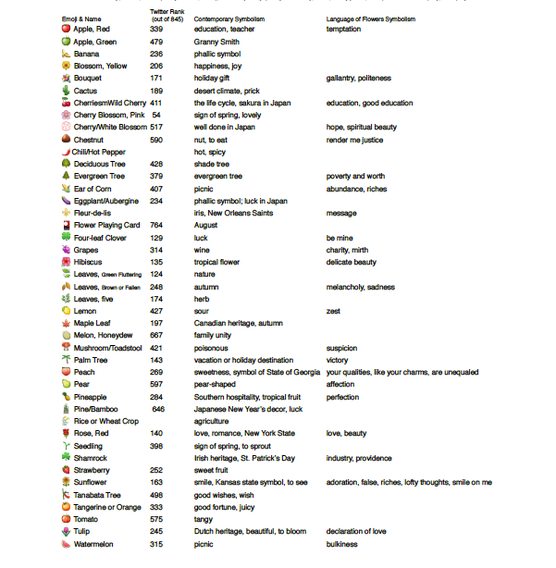
¹Emojitracker, 2016; ²Emojidictionary, 2016; ³Emojipedia, 2016; ⁴Loy, 2001
Many of the contemporary flower emoji sentiments could be found in a typical Victorian language of flowers dictionary, including education, family unity, good wishes, happiness, love, lovely, romance, and sweetness. Like the Victorian language of flowers, flower and plant emoji symbolism often relies on a characteristic of the plant for its significance: mushroom means poisonous because they can be poisonous, grapes are associated with wine, lemon with its sour taste. Several emoji are associated with a season like brown leaves with autumn and the seedling with spring. The pink cherry blossom is popular worldwide as a symbol of spring, while the white flower emoji has a special meaning in Japan, “well done.” Several emoji are associated with holidays such as the pine/bamboo decoration with New Years, the shamrock with St. Patrick’s Day, and the bouquet with birthdays, Mother’s Day, and other holidays. Local geography stills informs some emoji flower symbolism: for example, the fleur-de-lis signifies the New Orleans Saints football team to some and French royalty to others, cactus is used most in Arizona, the maple leaf is a symbol of Canadian heritage, and the tulip of Dutch heritage. It should be noted that if there is one universal in flower symbolism it is of course the queen of flowers, the red rose, which worldwide has and continues to signify love.

Cultural and geographical difference in flower symbolism
The differences of flower symbolism have depended greatly on regional geography. Plants that grew readily in a region and became familiar tended to become symbolic. The main similarity between Eastern and Western flower symbolism has been the method of explaining a flower’s meaning as it relates to the season or month. The plants in the Chinese and Japanese flower calendars have been similar in that at least half of the months are seasonal flowering trees. Chrysanthemum and poppy have appeared on Eastern and Western flower calendars because species of these flowers have grown in both hemispheres. Western flower calendars have been mainly flowers of the season. Although specific flowers have had different meanings from culture to culture, the meanings themselves have been similar, with sentiments such as affection (tree peony, carnation), beauty (plum blossom, rose), longevity (peach, plum, pear), love (peony, rose, carnation), purity (lotus, pear, water lily), truth (lotus, carnation), and youth (wisteria, primrose). The Victorians expanded the symbolic flower lexicon considerably with more than 1,400 flowers, herbs, trees, and plants and more than 1,500 different sentiments. The lists of plants in language of flowers books grew to include additional species native to North and South America such as calla lily, Carolina allspice, and coreopsis. This expansion of the flower lexicon was made possible by an intricate connection to the natural world and local plant knowledge.
As humans move away from a close connection with the natural world and as local geography loses its influence on language, flower symbolism is changing. The florist industry has attempted to revise Flowers of the Month calendars to represent common florist flowers, substituting iris in February and lily in May and calling larkspur “delphinium” and calendula “marigold.” The most significant change will come through the Internet, which offers incredible details and images of thousands of flowers and plants from all over the world, on the one hand, and on the other, offers a simplified flower lexicon in the form of emoji. Some flower emoji maintain a connection with season and geographic locale, but they are removed from the rich flower lore and botanical detail associated with the Victorian language of flowers.
Flower, plant, and fruit emoji are popular. The SwiftKey Emoji Report analyzed emoji usage from Cloud data from October 2014 to January 2015, in 16 languages and regions. The report mapped emoji use by state and found that plants are the most popular emoji in 10 states: Arizona/cactus, Idaho/ sunflower, Iowa/corn, Michigan/strawberry, Minnesota/peach, Nevada/eggplant, New Hampshire/fluttering leaves, Pennsylvania/cherries, Texas/grapes, and West Virginia/fallen leaves (Swiftkey, 2015a).
Worldwide findings from this survey include the following (Swiftkey, 2015b):
- Worldwide, flowers ranked 11th out of 60, plants ranked 31st, and fruit ranked 39th
- Arabic speakers used flower and plant emoji more than four times the average
- Flowers accounted for .9% of overall usage and .75% of U.S. usage
- The rose emoji accounted for 2.23% of worldwide emoji usage
- Arabic speakers used the rose emoji more than 8 times the average
- North Americans lead the world in use of the eggplant emoji
- Italians lead in banana emoji use
- The sprout was the most popular in the plant category with 9 times the average usage, followed by the palm tree at 4.6 times the average

Summary
The tradition of associating flowers with sentiments is ancient and universal, and the types of sentiments that flowers symbolize are similar from region to region. Individual flower associations, however, vary greatly from culture to culture and region to region, such that there is not one lexicon of agreed upon meanings. Ancient Chinese Flowers of the Month calendars established the tradition of associating flowers with symbolic meanings and these calendars spread to Japan, the Middle East, and Europe following traditional trade routes. Ancient Romans used seasonal flowers as birthday gifts. From published letters, the Turkish language of flowers and objects, sélam, became known in Europe as a system of associating flowers with sentiments. By the early 1800s the phrase, “the language of flowers,” was commonly recognized in Europe, and lists of regional flowers with their symbolic meaning began to be hand copied. The publication of de Latour’s Le langage des fleurs in 1819 began the great proliferation of language of flowers books in France, England, North America, and elsewhere. North American language of flowers books added species native to North and South America. The development of a detailed language of flowers lexicon relied on a deep connection and proximity to the plant kingdom. As the language of flowers developed in France, England, and North America plant lists adapted to regional geography and climate. Contemporary artists, designers, florists, marketers, and writers continue to use the language of flowers in isolated instances.
Local and regional geography continue to play a role in emoji plant symbolism, but in relation to team mascots, national emblems, and national holidays, rather than in relation to local flora, and emoji lack the depth of detailed botanical characteristics and classical lore that informed the Victorian language of flowers. Climate and blooming season continue to influence the symbolic meaning and use of some plant emoji. Flowers remain symbolic, and people continue to use them for symbolic purposes; however, the flower lexicon is contracting, compared with the expansiveness of the Victorian language of flowers. As people lose a close connection with the natural world and as the Internet replaces local geography, flower and plant symbolism is becoming simpler, less site-specific, and more universal. Flower and plant emoji symbolism is relatively young in its development and remains to be studied.

Books mentioned in the text
- Henry Adams (1844) The Language and Poetry of Flowers
- George Daniels (1891) The Floral Kingdom: Its History, Sentiment and Poetry
- Aubry de la Mottraye (1732) A. de la Motraye’s Travels Through Europe, Asia, and into part of Africa
- Charlotte de Latour (1819, 1834) Le langage des fleurs
- B. Delachenayes (1810) Abécédaire de Flore ou language des fleurs
- Vanessa Diffenbaugh (2011) The Language of Flowers: A Novel
- Kate Greenaway (1884, 1992, 2013) The Language of Flowers
- Sarah Josepha Hale (1832) Flora’s Interpreter; or, The American Book of Flowers and Sentiments
- Sarah Josepha Hale (1848) Flora’s Interpreter and Fortuna Flora
- Lucy Hooper (1841) The Lady’s Book of Flowers and Poetry
- C. M. Kirtland (c. 1882) Poetry of Flowers
- Catherine Klein (c. 1900). The Language of Flowers. Boston:
- Susan Loy (2001) Flowers, The Angels’ Alphabet: The Language and Poetry of Flowers
- Alexis Lucot (1819) Emblêmes de Flore et des végetaux
- Thomas Miller (1847) The Poetical Language of Flowers; or, The Pilgrimage of Love
- Lady Mary Wortley Montagu (1763) Turkish Embassy Letters
- Frances Osgood (1841) The Poetry of Flowers and Flowers of Poetry
- Henry Phillips (1825) Floral Emblems
- Sheila Pickles (1990) The Language of Flowers
- Sheila Pickles (1993) Forget-Me-Not: A Floral Treasury
- Margaret Pickston (1968) The Language of Flowers
- Frederic Shorberl (1834) The Language of Flowers: With Illustrative Poetry
- Robert Tyas (1836) The Sentiment of Flowers; or, Language of Flora
- Elizabeth Gamble Wirt (1829) Flora’s Dictionary
- P. van Zweeden. (1842). Albumbersjes en Bloemenspraak

References
Anderson, F. (1977). An Illustrated History of the Herbals. New York: Columbia University Press.
Eliot, B. (1993). “Say It With Flowers.” The Garden Journal of the Royal Horticultural Society, 118: 371-73.
The Emoji Dictionary. (2016). Available at emojidictionary.emojifoundation.com/. Retrieved: March 2016.
Emojipedia.org (2016). Accessed March 26, 2016.
Emojitracker.com. (2016). www.emojitracker.com, accessed March 19, 2016.
Field, A. and Scoble, G. (2014). The Meaning of Flowers: Myth, Language & Lore. Kindle Edition. San Francisco: Chronicle Books LLC.
Friend, H. (1886). Flowers and Flower Lore. London: Swan Sonnenschein, Le Bas & Lowrey.
Greenaway, K. (1884, 2013). The Language of Flowers.
Halsbad, R., Ed. (1967). The Complete Letters of Lady Mary Wortley Montagu 1708-1720. Oxford: Oxford University Press. Vol. I.
Hamilton, E. (1942). Mythology: Timeless Tales of Gods and Heroes. Boston: Little, Brown and Company.
Krythe, M. (1966). All about the Months. New York: Harper & Row, Publishers.
Lehner, E. and Lehner, J. (1960). Folklore and Symbolism of Flowers, Plants and Trees. New York: Tudor Publishing Company.
Loy, S. (2001). Flowers, the Angels’ Alphabet: The Language and Poetry of Flowers. Moneta, VA: CSL Press.
McClintock, P. (2011). “‘The Language of Flowers’ Film Rights Optioned by Fox 2000.” Retrieved March 20, 2016 from www.hollywoodreporter.com/news/language-flowers-film-rights-optioned-233478.
Negishi, M. (2014). “Meet Shigetaka Kurita, The Father of Emoji.” Retrieved March 25, 2016 from http://blogs.wsj.com/japanrealtime/2014/03/26/meet-shigetaka-kurita-the-father-of-emoji/
Seaton, B. (1995). The Language of Flowers: A History. Charlottesville: University Press of Virginia.
Shorberl, F. (1839). The Language of Flowers; with Illustrative Poetry: To which is now first added, The Calendar of Flowers. Philadelphia: Lea & Blanchard.
SwiftKey. (2015a). “The United States of Emoji.” Retrieved: March 20, 2016 from https://swiftkey.com/en/united-states-emoji.
SwiftKey. (2015b). “Most-used emoji revealed: Americans love skills, Brazilians love cats, the French love hearts.” Retrieved: March 19, 2016 from https://blog.swiftkey.com/americans-love-skulls-brazilians-love-cats-swiftkey-emoji-meanings-report/

Pedanius Dioscorides (40-90 A.D.) was a Greek physician, pharmacologist, and botanist who wrote “De Materia Medica,” an encyclopedia of herbal medicine.

